Macintosh, Microsoft Office 2004, and Microsoft Access
Commentary by Jim Gordon February, 2006

Microsoft Access does not exist for MacOS and probably will not any time in the next few years. Microsoft’s Macintosh Business Unit (MacBU) has had its hands full for the past few years dealing with changes in Macintosh OS and hardware changes. During the near future they will be busy dealing with making their products work on Intel hardware and making Office file formats match the new open XML file format standards that will be incorporated into Office 12 for Windows and Vista.

Office 2004 can do the following with Microsoft Access .mdb database files:
- Get data from Access files in table, pivot table and list formats
- Use Structured Query Language (SQL) Select statements
- Get data using a Graphical User Interface (Microsoft Query)
- Create form letters, labels, envelopes and catalogs
  - Merge to printers, email and other documents
- Limited automation is available via Microsoft Visual Basic and AppleScript

In order to do the above it is necessary to install additional 3rd party software that is not included with Microsoft Office. Microsoft Office does not come with ODBC drivers for Macintosh or Microsoft Windows. Microsoft Windows operating system includes a Microsoft Access ODBC driver, but Apple Mac OS does not. Hence, Mac users need to obtain a 3rd party driver for Microsoft Access.

As of this writing there are two companies making Macintosh ODBC drives for Microsoft Access: OpenLink™ Software and Actual Technologies, LLC

Limitations of Office 2004
- Interaction with Microsoft Access is “Read-Only.” Office 2004 can not add or delete records, fields, tables or create new Access databases.
- The ODBC visual basic add-in is not available.
- SQL is limited to Select statements. Joins are supported in SQL and are visible in the graphical user interface.
- Word can not directly connect using ODBC. Use Excel and then use Word’s data merge manager to automate Word.
- Only tables and views are available from Acess databases. Forms and reports must be created with Office 2004 on the Mac usign Excel and Word.

Which Driver?
The Actual Technologies driver connects to any Access .mdb file that can be reached using MacOS Finder. It will connect to any MS Access .mdb file that’s located within your Mac’s file system or on any mounted volume using MacOS with WebDav (faster), SMB (slower) and with volumes mounted by Thursby’s networking products.

The OpenLink driver makes a network connection to Access .mdb files located on computers other than your Mac. It is not necessary to mount a volume to your desktop to connect to a remotely located Access .mdb file. However, you can not navigate in finder to an Access .mdb file that’s located on your own file system. The OpenLink driver requires a driver to which it can connect on the host (Windows) computer.

Both companies provide a downloadable disk image .dmg file that opens into an installer. I would like to point out that if you use the Actual Technologies driver that the second screen of the installer, Important Information, is something you should print out because it has details about how to set up the driver. It really is important information.

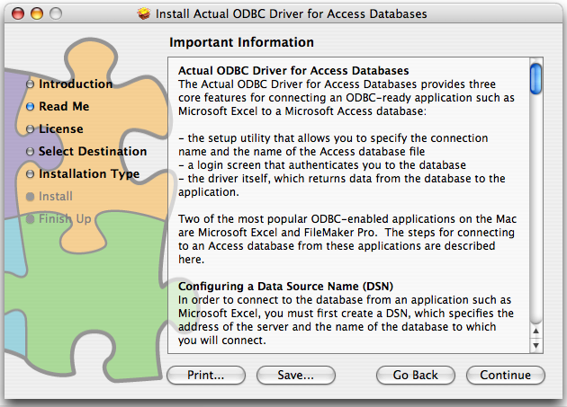

Where is the Access MDB File Located?
You need to know this before you can make a connection.

It is very easy to mount (map) a Windows volume containing an Access MDB file to the Macintosh desktop in Mac OS 10.3 and especially 10.4.

To connect to a Windows network using Active Directory:
From the Mac desktop click the GO menu and choose CONNECT TO SERVER
Here’s an example of what to enter:
smb://ad;username@servername/sharename/

To connect to a Windows network using network:
From the Mac desktop click the GO menu and choose CONNECT TO SERVER
Here’s an example of what to enter:
smb://username@servername/sharename/

To connect to a Windows network using WebDAV in Tiger 10.4 or later:
From the Mac desktop click the GO menu and choose CONNECT TO SERVER
You will need to obtain the proper URL to use from the administrator of the host computer. Here’s one example, but your string could look quite different:
https://webfolders.buffalo.edu/user/u/s/username/ub/
WebDAV connections are preferred because they are very fast.

If you need to connect often you can make an AppleScript do the work. Here’s an example:
tell application "Finder"
mount volume "smb://ad;username@servername/sharename/"
mount volume "https://webfolders.buffalo.edu/user/u/s/username/ub/
end tell
You can save the script as an application and then use the System Preferences for the user to make the application a log-in item so that whenever the computer is started the script runs and mounts the windows volumes to the desktop.

If you use any of the above methods you should use the Actual Technologies ODBC driver since you will be able to navigate to the Access MDB file using MacOS Finder.

There may be times you are unable to connect using finder. In those cases you may need to make a network connection between the ODBC driver on the Mac and an ODBC driver on the host Windows computer. In this scenario use the OpenLink driver.

Which Database to connect to using which driver?
You can connect to as many different databases using as many different drivers as you want to. Use an ODBC Administrator to add and remove connections.

MacOSX comes with ODBC Administrator. If you install the OpenLink driver you will get their ODBC administrator. Both work pretty much the same way.
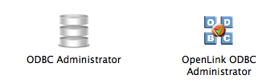

Choose either System DSN or User DSN.
- Click the User DSN to make a data source available only to the user currently logged in to this computer. This is usually the option to take.
- Click the System DSN tab if you want a data source to be available to all the users on this computer. This is tricky to set up. You must be an administrator of your Mac.
Click the ADD button. Go through the Administrator wizard and fill in the blanks. You may need to unlock the control panel with your system password (click the lock in the lower left corner if it is locked).

The wizard uses some jargon: DSN means Data Source Name. The DSN is the name you give to the connection to the Access database in the Administrator wizard so that later on you can select it to connect to that mdb file. The idea is to build a list of connections to various databases in a way so you can tell which database to connect to from Excel (or any other ODBC enabled program).

The list will appear whenever you use a program that wants to connect to a data source.

At a minimum the ODBC dialog box needs to know 3 things:
- The name of the database (type a short name)
- A description (type a short description)
- Which ODBC driver will be used for this connection (select from a list of ODBC drivers installed on the computer)

Use ADD to make an entry for each Access mdb file you want to be able to connect to.

Let’s get some data
Example #1 – Import an entire table from Access into Excel.
Excel limitation: The maximum number of rows Excel can accept is 65,536.
Open Excel to a blank workbook
Switch to Normal view

From the DATA menu choose GET EXTERNAL DATA > NEW DATABASE QUERY

The ODBC Administrator will open.

You must click on a data source from the list then click OK. Even if there is only one data source, you must first click on it to select it in order to make a connection.

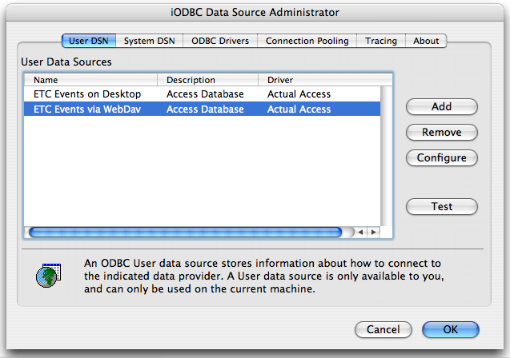

Microsoft Query will open. There is a main window divided into 3 panels. Also, there is a window that lists the tables in the Access database.

- Select a table name and click the Add button or double-click a table name and it will appear in the table panel.

- Change the FIELD selector to the table name with the asterisk * to select the entire table.

- Click TEST to display the records in the bottom panel.

- Click the RETURN DATA button to bring the table information into Excel. Excel will offer a variety of options that control how Excel will treat the data once the import has been completed.

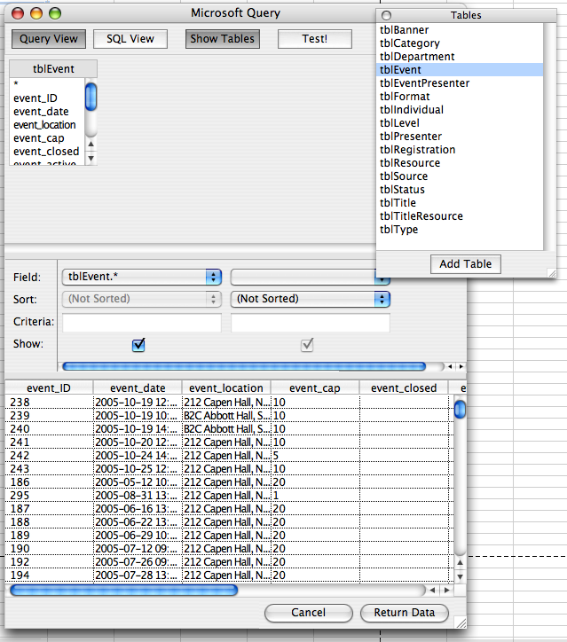
1
2
3
4
Columns and fields can be dragged in the interface to change their order. Use FIELD to display desired fields. Right-click a table to delete it from a query.

Example #2 – Filter Records

The middle panel of MS Query panel is controls for which fields will be selected and what criteria will be used for the selections.

This example shows how to filter to find records that contain the word “Brochure” from the table tblSource.

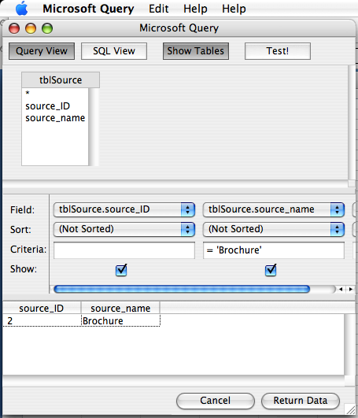

The SQL View button displays the Structure Query Language of the Query View. If you type SQL into the SQL View and switch to Query View then MSQuery will attempt to execute the SQL you typed.

SELECT tblSource.source_ID, tblSource.source_name FROM tblSource WHERE (tblSource.source_name = 'Brochure')

Switch back and forth between these views to learn the syntax that MSQuery uses for SQL. Note the use of parenthesis.

Example #3 – Multiple table query
MSQuery makes Excel a relational database tool. By joining two tables together, you can limit the result set that is returned to eliminate duplicate records.

To join two tables, first put two tables into the top panel of MSQuery. Drag a field that both tables have in common from one table into the other. MSQuery may prompt you for the field names if it can not determine matched fields automatically.

A line joining the two tables will appear. You can double-click the line to edit the join.

You can perform any SELECT query that Microsoft Access supports.

Be advised that it is possible to easily make queries that produce very large number of results. Make your joins before clicking TEST or RETURN DATA.

This query lists the names of everyone who registered for any workshop and found the workshop information from our brochure:

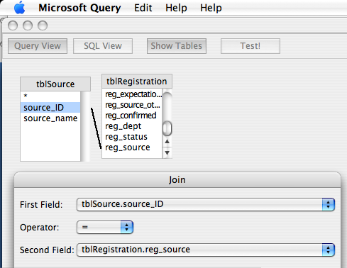

SELECT tblRegistration.reg_name_first, tblRegistration.reg_name_last, tblSource.source_name FROM tblRegistration, tblSource WHERE (tblSource.source_name = 'Brochure') AND (tblSource.source_ID=tblRegistration.reg_source)

Example #4 – Count number of records
This query has a result set but can not be displayed in Query View

SELECT count(Reg_Event) FROM tblRegistration
Example #5 – Match a string of text
There is an SQL command called LIKE that will search through the text within a field and return records that match the text string.
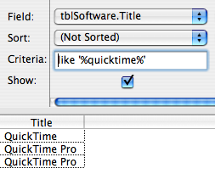
This example shows how to search for the word final in a field called tblSoftware.Title.

To use the LIKE command, in the Criteria field type the word like followed by a space then surround the search characters in single quotes and percent signs as shown.

SELECT tblSoftware.Title FROM tblSoftware WHERE (tblSoftware.Title like '%quicktime%')

Example #6 – Show only the unique records within a column
Sometimes a column will have repetitive (identical) records within it, like the example above. To return a set of records that contains only one of each unique entry within a field, add DISTINCT to the SQL command. You will need to switch to SQL view in order to do this. Example adding DISTINCT to the example #5, then click the TEST button. You can’t switch to QUERY view.

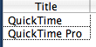
SELECT distinct tblSoftware.Title FROM tblSoftware WHERE (tblSoftware.Title like '%Quicktime%')

Example #6 – Group records
You must be in SQL View. Click the TEST button to view result set of records.
You can not switch to QUERY view. Example:

SELECT tblRegistration.name FROM tblRegistration group by name

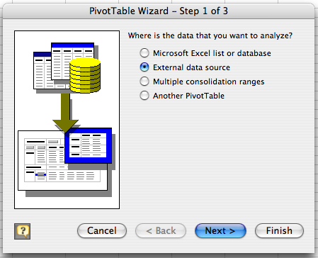
Example #7 – Make a pivot table in Mac Excel directly from an Access database

On a worksheet in Excel, from the DATA menu choose PIVOT TABLE REPORT. In step 1 click the EXTERNAL DATA SOUCE button. Then follow the steps through the wizard to choose a database connection and get the data you desire.

Help keep this information current. Send updated information about this document to Jim Gordon

The Actual Technologies driver also works with FileMaker Pro
The OpenLink driver is a general-purpose driver that supports a variety of products

